Inventory must be updated for the associated shipment in order for an invoice to be approved.
SO23040084:
Attempting to update inventory for PS23040843 indicates there is insufficient inventory for the item on line 2 of the shipment

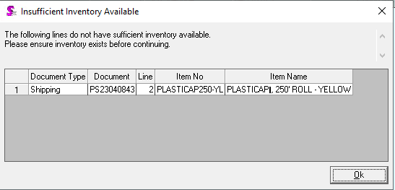
Right click on line 2 of the shipment and select Inventory Lookup. You will see that there is no inventory for item PLASTICAP250-YL.
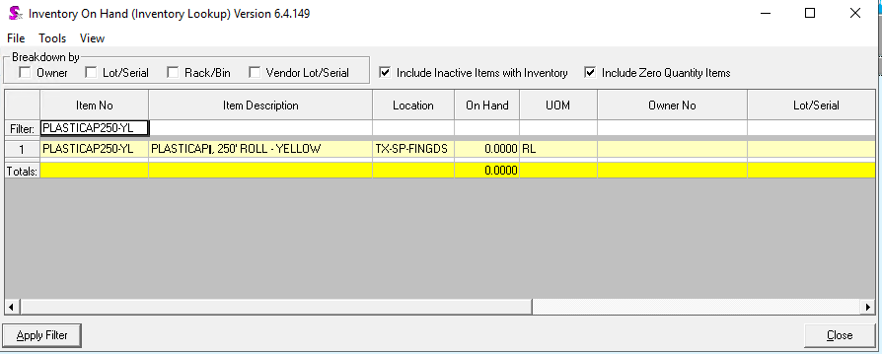
Since the item is tracked in inventory, you must create inventory in order to update inventory for the shipment.
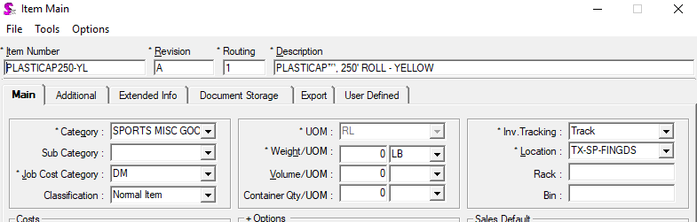
If you have no open purchase order that have not yet been received, create an inventory adjustment to add the inventory you have physically on hand for PLASTICAP250-YL into the system. Once this done you will be update to update inventory for PS23040843 (using the Tools > Update Inventory option in Shipping) and then subsequently be able to approve the invoice.
SO23040089:
Inventory must be updated for PS23040832 in order to approve its invoice. Again, insufficient inventory exists for item FENCEGUARDLT-YL in the location being shipped from.
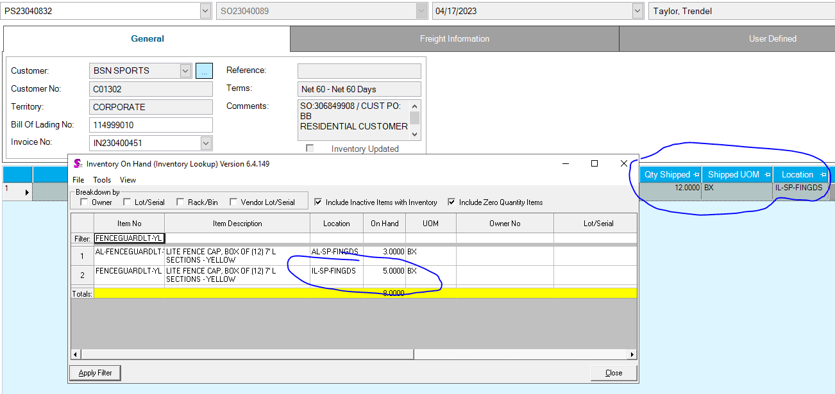
More inventory must be added for item FENCEGUARDLT-YL to location IL-SP-FINGDS to meet the requirements of the shipment. Once this is done you will be able to update inventory for the shipment.
SO23040086:
This again is an issue pertaining to insufficient inventory, but this time there is a twist. There is 20 RL of PLASTICAP250-RD in TX-SP-FINGDS; however, all 20 are allocated to a vendor return (VR2209005). This vendor return has been sitting unprocessed since January 17 of this year. VR2209005 needs to be either processed or unapproved and deleted. If the vendor return is deleted, this should make the inventory for PLASTICAP250-RD available to ship. However, if the vendor return needs to be processed, you will need to receive more inventory or adjust more in.

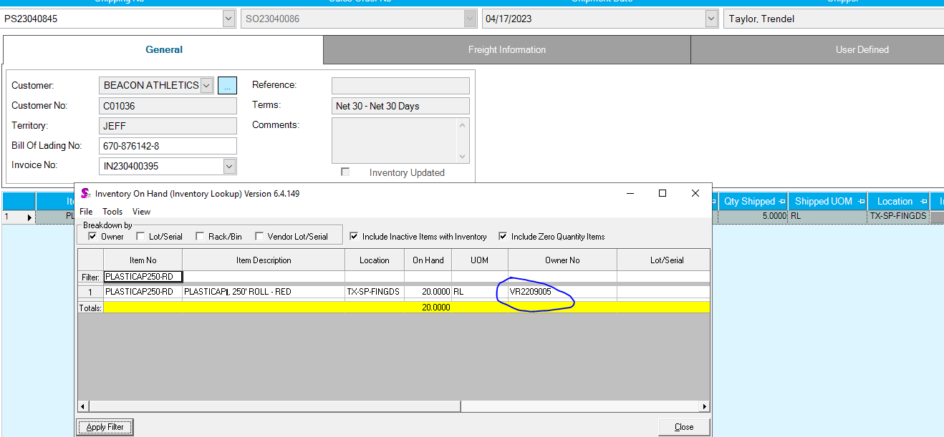
SO23031047:
This is also a problem created by insufficient inventory being available.
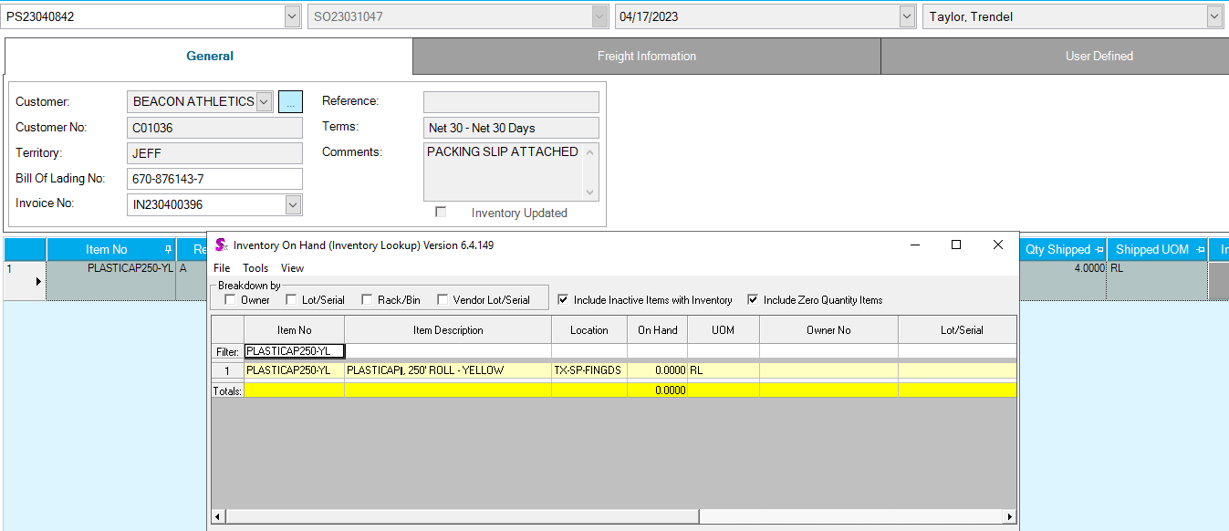
Once inventory is corrected for the item you will be able to update inventory for PS23040842.

